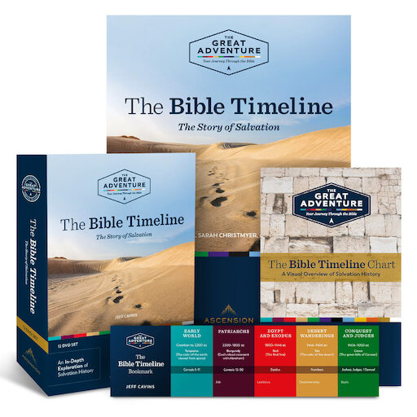

**WEDNESDAYS 9:30-11:30 AM**

**Beginning September 20, 2023**

**OR**

**SUNDAYS 3:00-5:00 PM**

**Beginning September 24, 2023**

Sacred Heart Church Parish Center

Bay Head, NJ

$25 for Workbook

REGISTRATION DEADLINE SEPT 10TH

For more Information contact:

Barbara Turro

Email: [barbara.turro@gmail.com](mailto:barbara.turro@gmail.com)

732-903-7551

In ***The Bible Timeline: The Story of Salvation***, presenter

Jeff Cavins will show you how fourteen of the Bible’s narrative books tell the biblical story from beginning to end.

Using a unique color-coded chart, you will learn the major

People, places, and events of the Bible and discover how they all come together to reveal the remarkable story of our faith.

***The Bible Timeline*** will teach you how to read and understand the bible and introduce you to the wonderful narrative of the Bible in a way that will transform your life.

*I never would have read the Bible if it wasn’t for this, and now I simply adore Scripture. It has given me such insight into the Catholic faith and helps me to understand its true beauty.*

*-Kyley D.*



