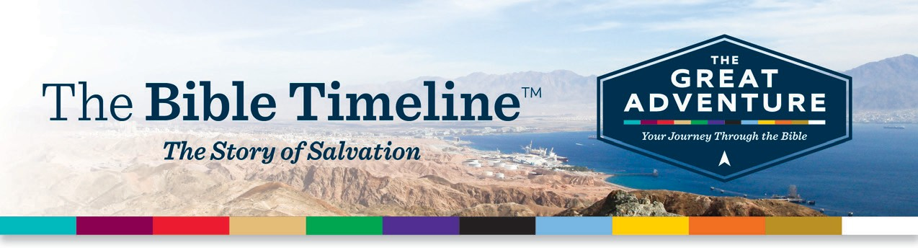

barbara.turro@gmail.com

To request assistance please email: Barbara.turro@gmail.com

08738

­­

­­

­­barbara.turro@gmail.com

­­



**STUDY REGISTRATION FORM**

.

GROUP CHOICE:

Visit ascensionpress.com to learn more about

***The Great Adventure***TM **Catholic Bible study program.**

**REGISTRATION OPTIONS**

Participant Fee: CASH Check

Checks payable to:

SACRED HEART CHURCH (Memo: Bible)

Mail to: Barbara Turro

1103 Barnegat Lane, Mantoloking, NJ 0873808738 Mantoloking, Nj

**PARTICIPANT INFORMATION**

Name: Address:

City: State, Zip: Email:

PHONE:________________________________________________

$25

WEDNESDAY MORNINGS 9:30-11:30

OR SUNDAY AFTERNOONS 3:00-5:00